Spam Email Detection System

Project Id: AIML-22

Name : KARTIKEYA BALI(Team Leader)
Class Roll Number:44
University Roll Number : 2028740
Section and Group: U,G2

Name :SUMEDHA THAKUR
Class Roll Number:62
University Roll Number : 2028870
Section and Group: U,G2

- Problem Description 3
- Architecture 3
- Models model 4
- Evaluation metrics used 4-5
- Preliminary Results and Visualizations 5-6
- References 6

1.Problem Description

Spam Email Detection System This system classifies emails as spam or not using text data. Text preprocessing includes removing stopwords, punctuation, and converting text to numeric features. Feature selection removes less important words and keeps high-impact spam keywords. Logistic Regression and SVM (Linear, Polynomial, and RBF kernels for different text patterns) are trained. Models are evaluated using confusion matrix and accuracy.
2.Architecture

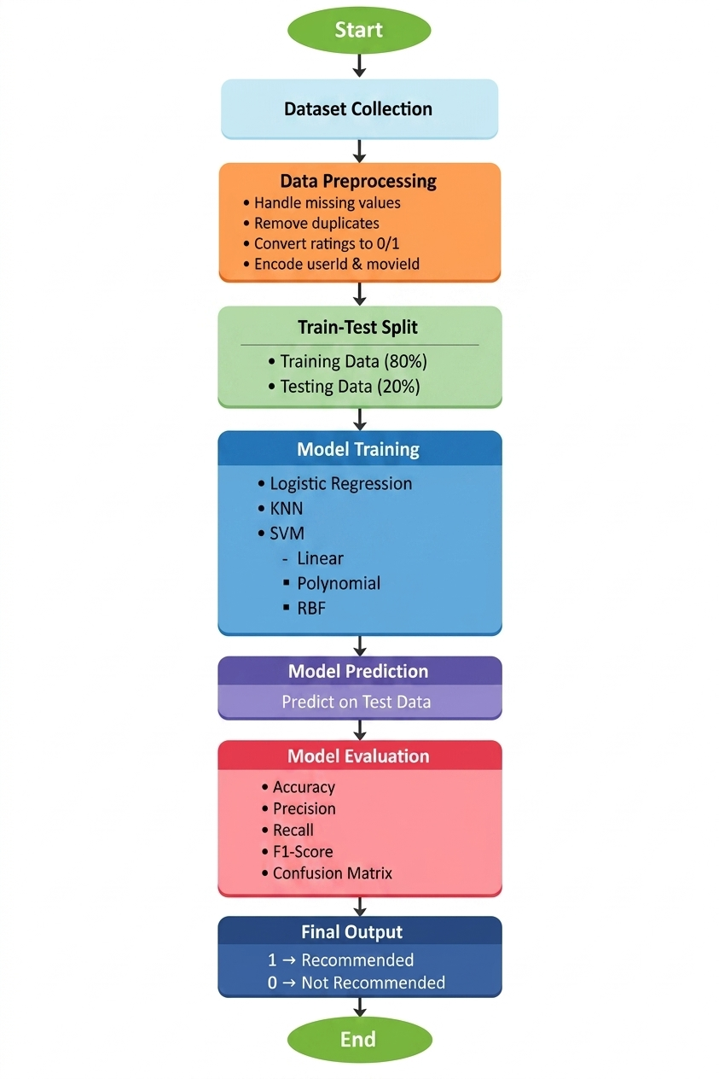

Fig.1 Sample flow diagram.

3.Models Used(Applied/ Planned) Give a brief introduction of the models used-

In the Spam Email Detection System, machine learning models are used to classify emails as spam or not spam (ham) based on textual data. After preprocessing and converting text into numerical features, the following models are applied:
1.LogisticRegression-
Logistic Regression is a supervised classification algorithm used for binary outcomes. It predicts the probability that an email belongs to the spam class using a logistic (sigmoid) function. It is simple, efficient, and performs well for text classification problems where relationships between features are mostly linear.
2.SupportVectorMachine(SVM)-
Support Vector Machine is a powerful classification algorithm that finds the optimal boundary (hyperplane) to separate spam and non-spam emails. Different kernels are used to handle various data patterns:
- Linear Kernel: Works well when the data is linearly separable and is commonly effective for text data.
- Polynomial Kernel: Captures more complex relationships by considering interactions between features.
- RBF (Radial Basis Function) Kernel: Handles non-linear patterns by mapping data into higher-dimensional space, making it useful for complex spam detection scenarios.
Model Evaluation
The performance of these models is evaluated using:
- Confusion Matrix: To measure true positives, true negatives, false positives, and false negatives.
- Accuracy Score: To determine the overall correctness of the model.

4.Evaluation metrics used-

To measure the performance of the Spam Email Detection System, the following evaluation metrics are used:
1.Accuracy-
Accuracy measures the overall correctness of the model. It is the ratio of correctly predicted emails (both spam and non-spam) to the total number of emails. It gives a general idea of how well the model is performing.
2.ConfusionMatrix-
A confusion matrix provides a detailed breakdown of predictions:
- True Positives (TP): Spam emails correctly identified as spam
- True Negatives (TN): Non-spam emails correctly identified as non-spam
- False Positives (FP): Non-spam emails incorrectly marked as spam
- False Negatives (FN): Spam emails incorrectly marked as non-spam
This helps in understanding where the model is making errors.
3.Precision-
Precision measures how many emails predicted as spam are actually spam. It is important when false alarms (marking normal emails as spam) need to be minimized.
4.Recall-
Recall measures how many actual spam emails are correctly detected. It is important when missing spam emails is costly.
5.F1-Score-
F1-score is the harmonic mean of precision and recall. It provides a balanced measure when both false positives and false negatives are important.

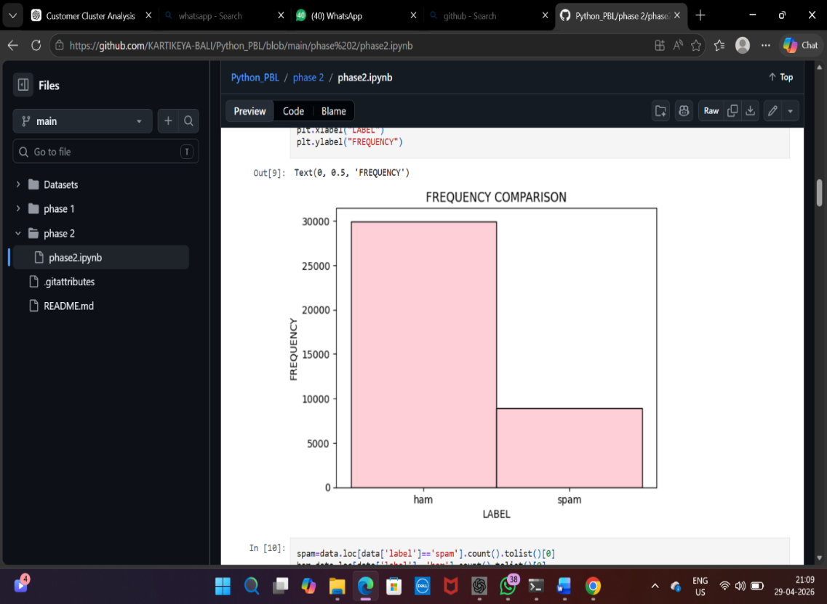
Fig.2-shows the frequency comaparison, i.e a histplot between label and frequency, before dropping
The ham emails

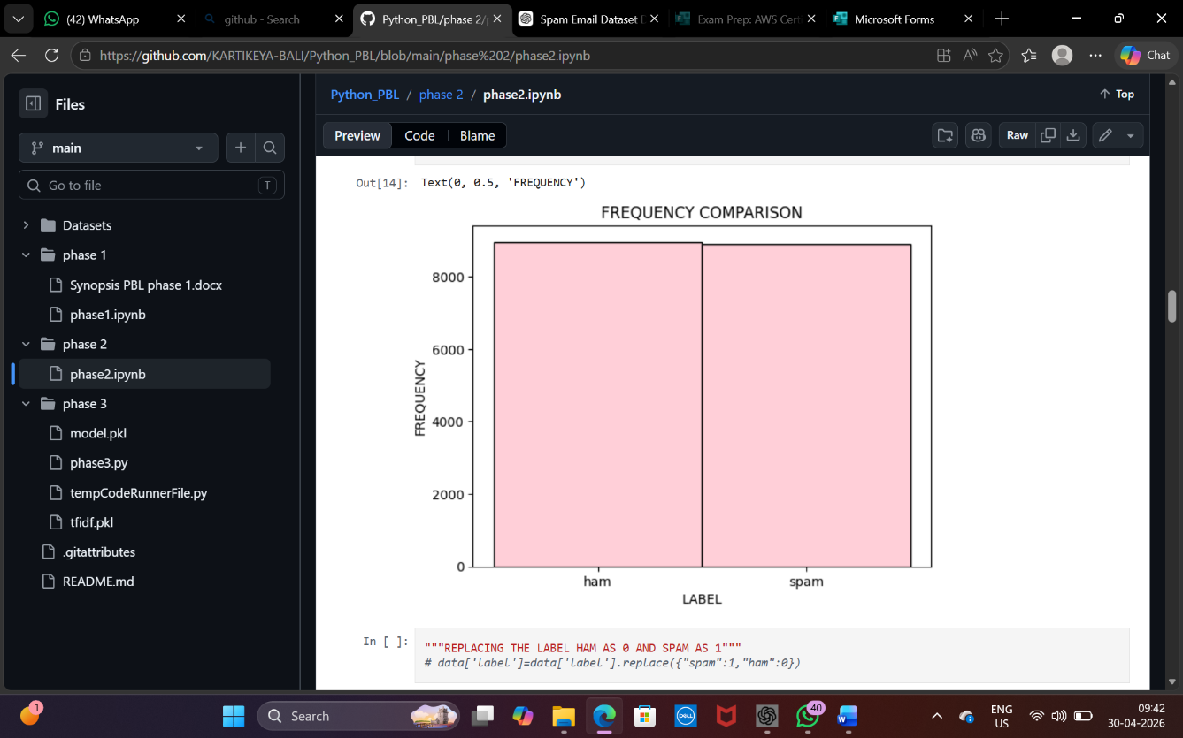

Shows the frequency comparison after dropping the ham emails

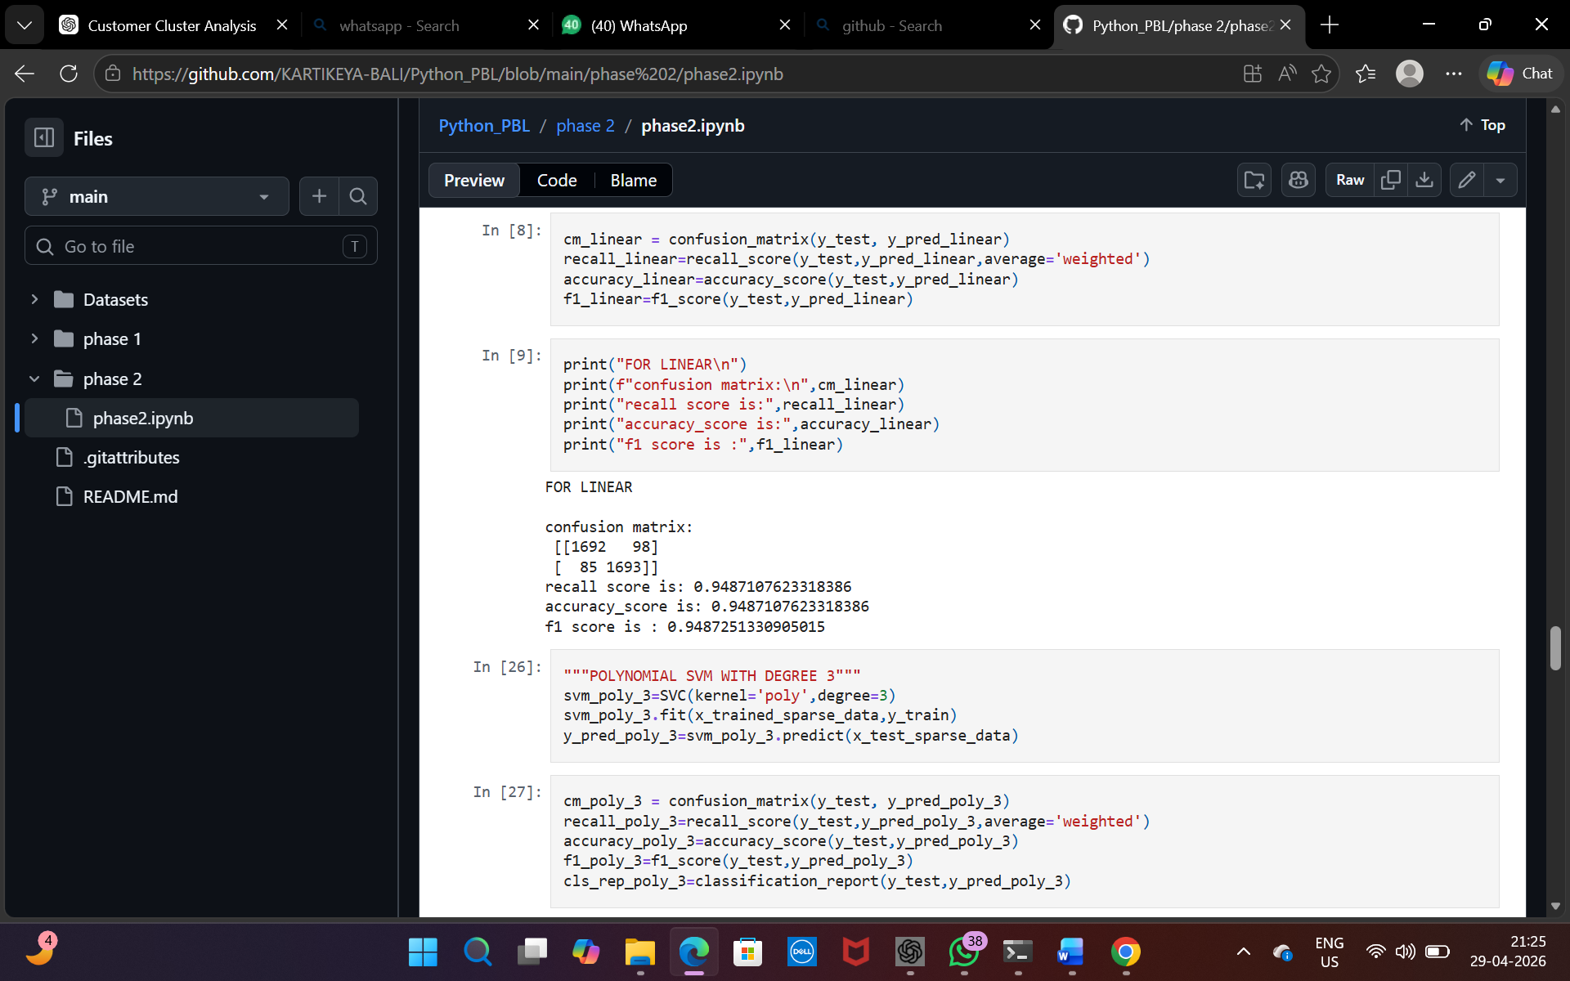
Fig.3 linear svm

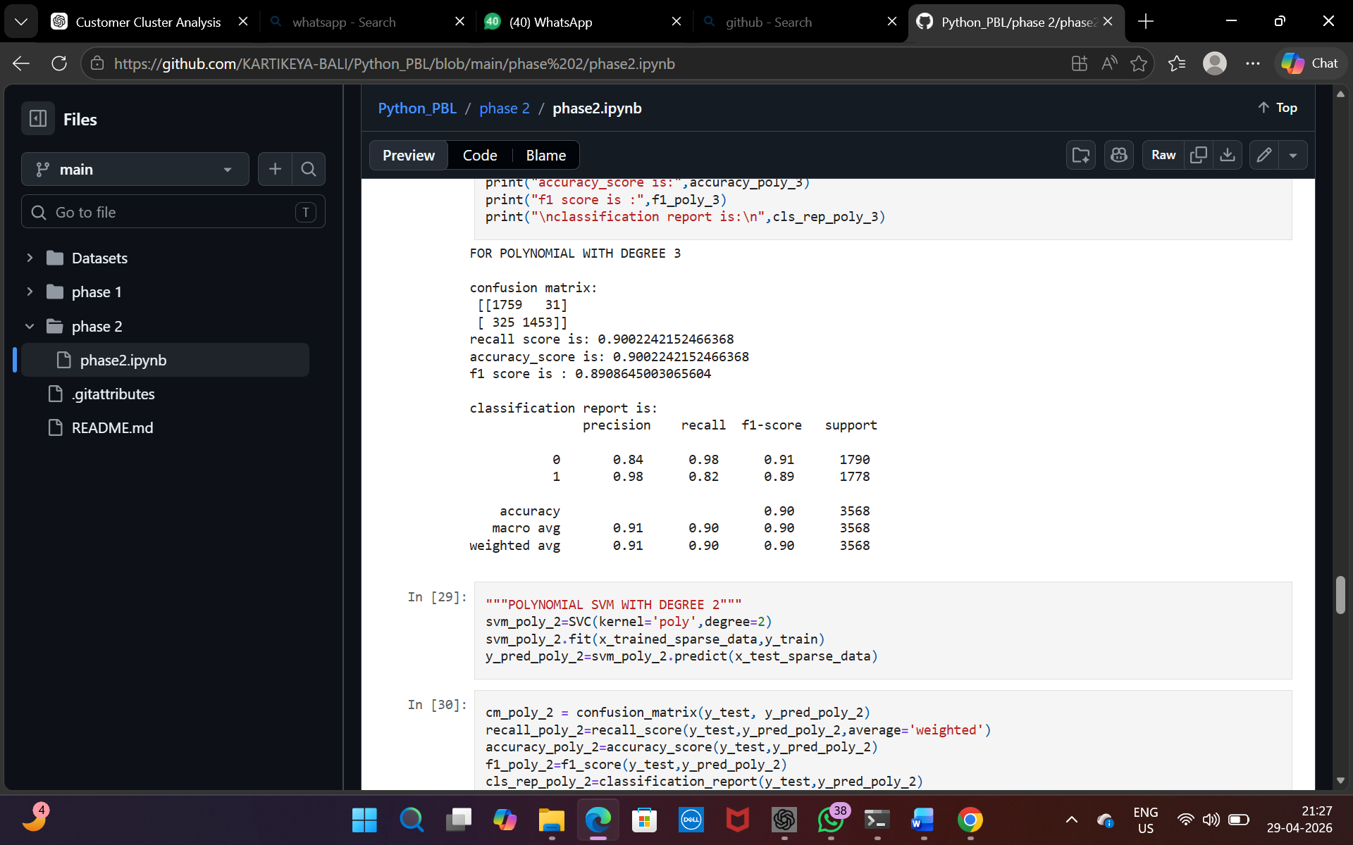
Fig.4 for polynomial with degree 3

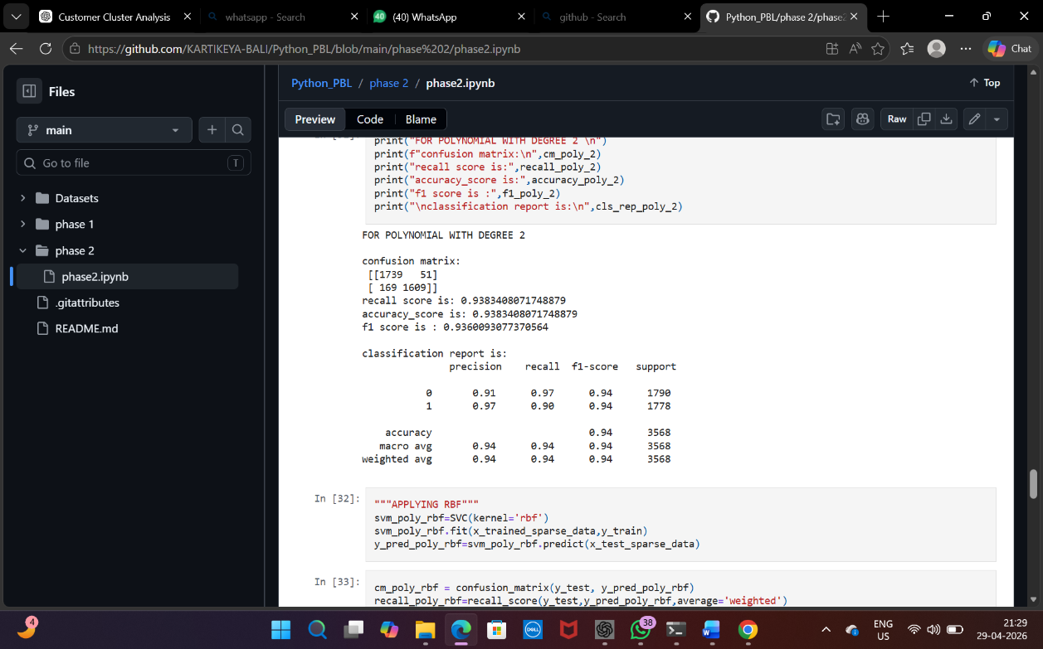
Fig.5 for polynomial with degree
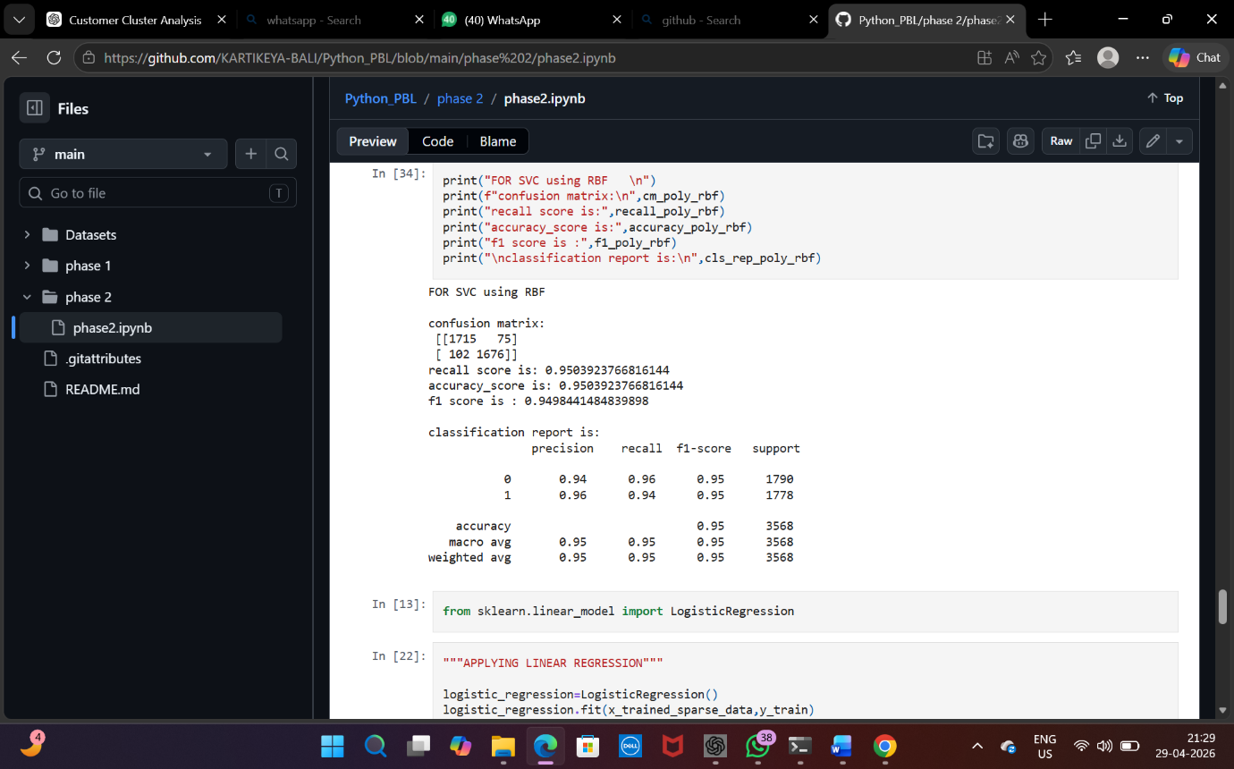
Fig.6 for svc using RBF

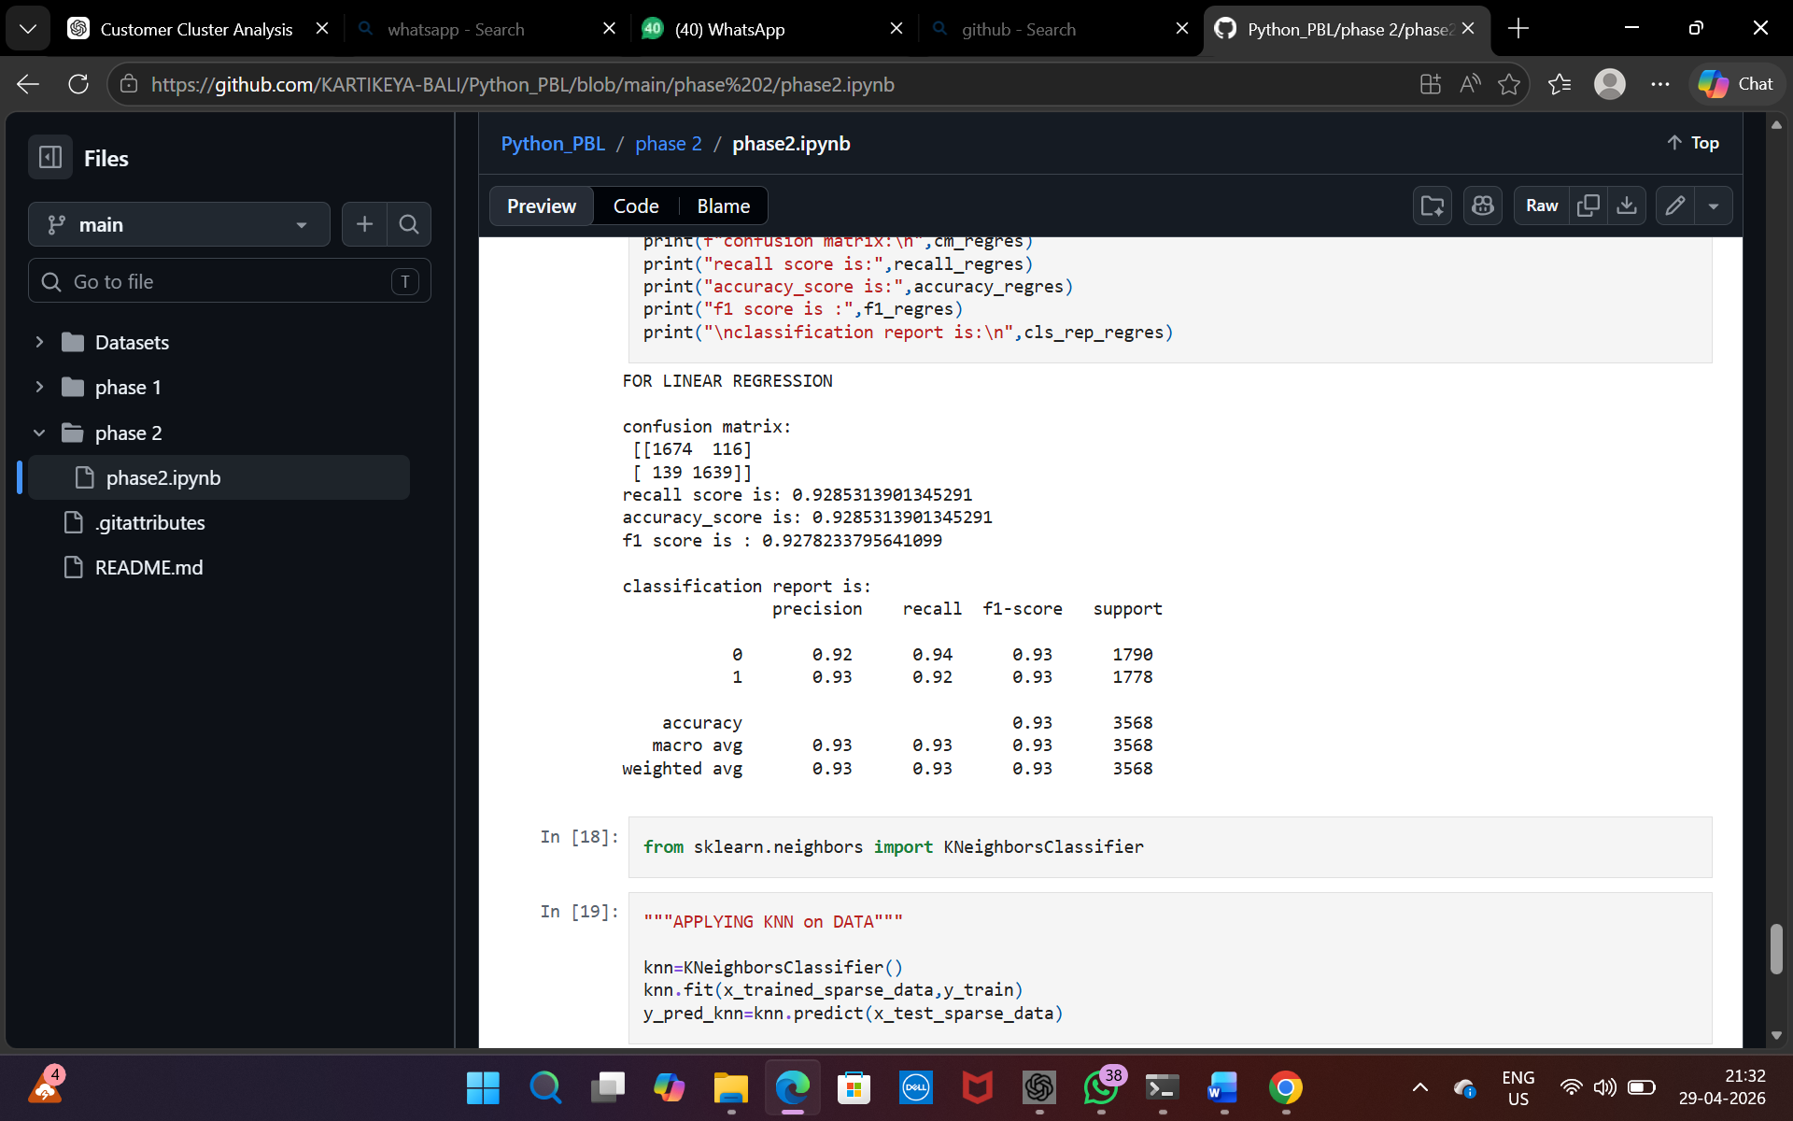
Fig.7 for logistic regression

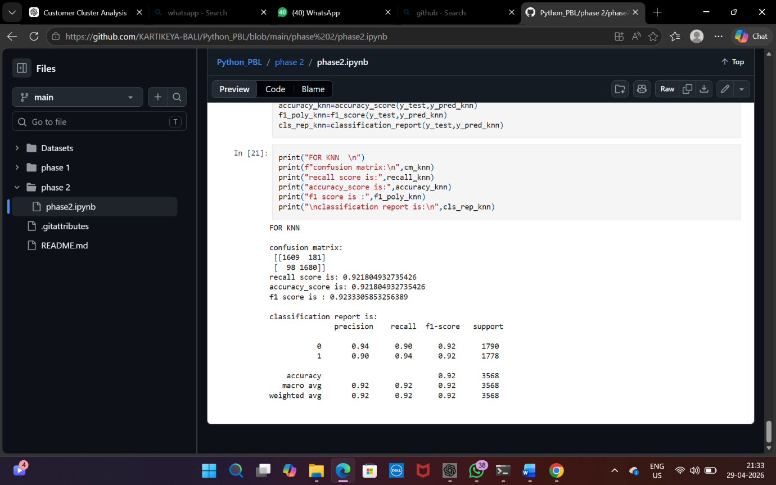
Fig.8 for knn

6. References:
Books:
- Let Us Python – Yashavant Kanetkar

Online Resources:
  - GeeksforGeeks – https://www.geeksforgeeks.org/
  - TutorialsPoint – https://www.tutorialspoint.com/cprogramming/index.htm
  - Stack Overflow – https://stackoverflow.com

